Contact:
Ken Hunter
PowerStation Communications
khunter@PowerStationComms.com
908-295-8946

NEW CHILDREN’S BOOK, HERMANN FINDS HOME, SHOWS KIDS HOW TO COPE IN UNFAMILIAR SITUATIONS

Debut Book by Veteran Journalist Nancy Lang-Feldman Chronicles the Journey of Hermann, a Tortoise in Search of Home Who Ultimately Discovers Life and Love

Part of Proceeds Benefit Tortoise Protection Non-Profits; Kickstarter Campaign Raising Funds for Plush Toy

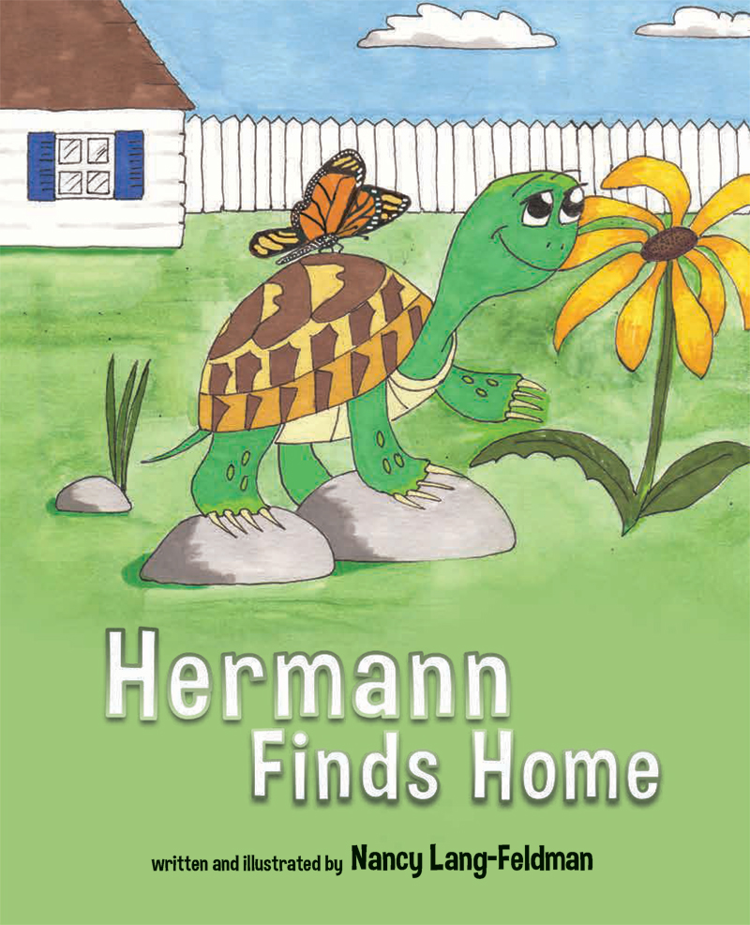
COMMACK, N.Y. (NOVEMBER 17, 2016) – Hermann Finds Home is a new children’s book for kids four through eight, that follows young tortoise Hermann as he sets out on an adventure, makes friends, grows up, and finds his perfect mate.

Hermann is an adorable tortoise who just wants to love and be loved. He enjoys playing with children and has a penchant for strawberries.

This children’s book – the first by veteran journalist Nancy Lang-Feldman – is special for kids because it chronicles how youngsters can overcome their fears when around strangers, find caring help if they get lost, and cope when they are put in unfamiliar situations.

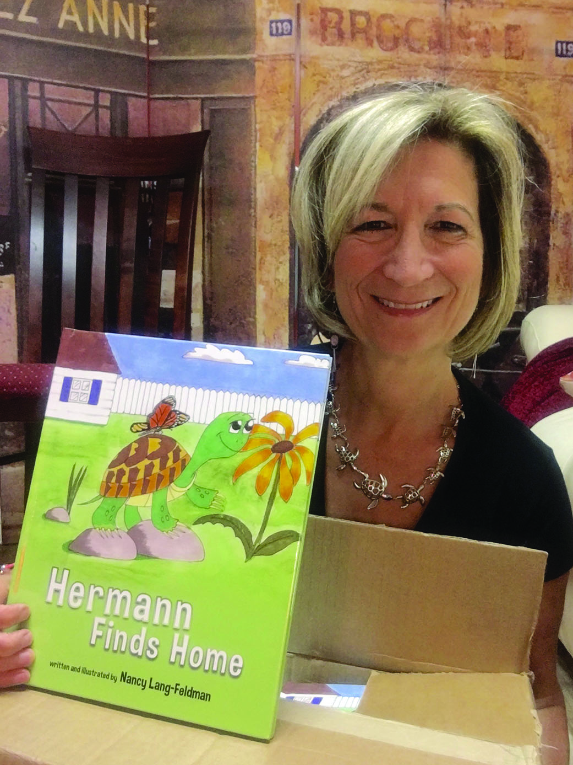
“Through the tale of Hermann the tortoise, children will learn that even when things seem impossibly bleak, there is always hope,” said Lang-Feldman. “And even if they don’t always find what they’ve been searching for, they might end up finding something just as good—or even better!”

The main character, Hermann, finds his perfect world turned upside down. His journey to find his way back home turns into an exciting adventure as he encounters some wonderful creatures, makes new friends, overcomes challenges, and explores the world around him.

Lang-Feldman wrote and illustrated Hermann Finds Home for her sister, Susan, who was heartbroken over the loss of her pet tortoise. She wanted to try to convince Susan that Hermann is alive and happy somewhere.

Proceeds Benefitting Tortoise Non-Profits
Hermann Finds Home will not only entertain children, it will educate them as well, with lots of fun facts about tortoises (read this review). Several charities providing care to tortoises will also benefit from sales of Hermann Finds Home, with a portion of the proceeds going to Galapagos Conservancy and Darwin Animal Doctors.

The book also spurred Lang-Feldman’s Kickstarter campaign, where she is raising funds to create a plush Hermann the Tortoise toy. Backers have the opportunity to get autographed copies of the book as well as the plush toy Lang-Feldman is hoping to create. The Herman the Tortoise plush will be made in the U.S. of certified-organic material by at-risk women from welfare-to-work programs. For every Hermann the Tortoise plush purchased, the manufacturer, Bears for Humanity, will donate a stuffed bear to a child in need.

About the Author and Hermann Finds Home:
Nancy Lang-Feldman boasts a significant career as a writer and editor. Focusing on health and fitness and computers and technology, she has worked at publications and websites including Consumer Reports, CNET, and Computer Shopper. She has a Bachelor of Fine Arts with a specialization in journalism from Long Island University. Lang-Feldman lives on Long Island with her husband Rob.

Hermann Finds Home (ISBN 13 978-1-63177-684-7) is registered with the American Wholesale Book Company, Baker & Taylor, Follett Library Resources, and Ingram. The book is available for purchase for $14.95 at www.HermanFindsHome.com, and is also available at retailers including Amazon, Barnes & Noble, and more. Hermann Finds Home is published by Rex Imperator, an independent publisher founded in 2011 that specializes in literary fiction, true crime, poetry, and children’s literature. Learn more at www.rex-imperator.com.

# # #

